Amy Mara
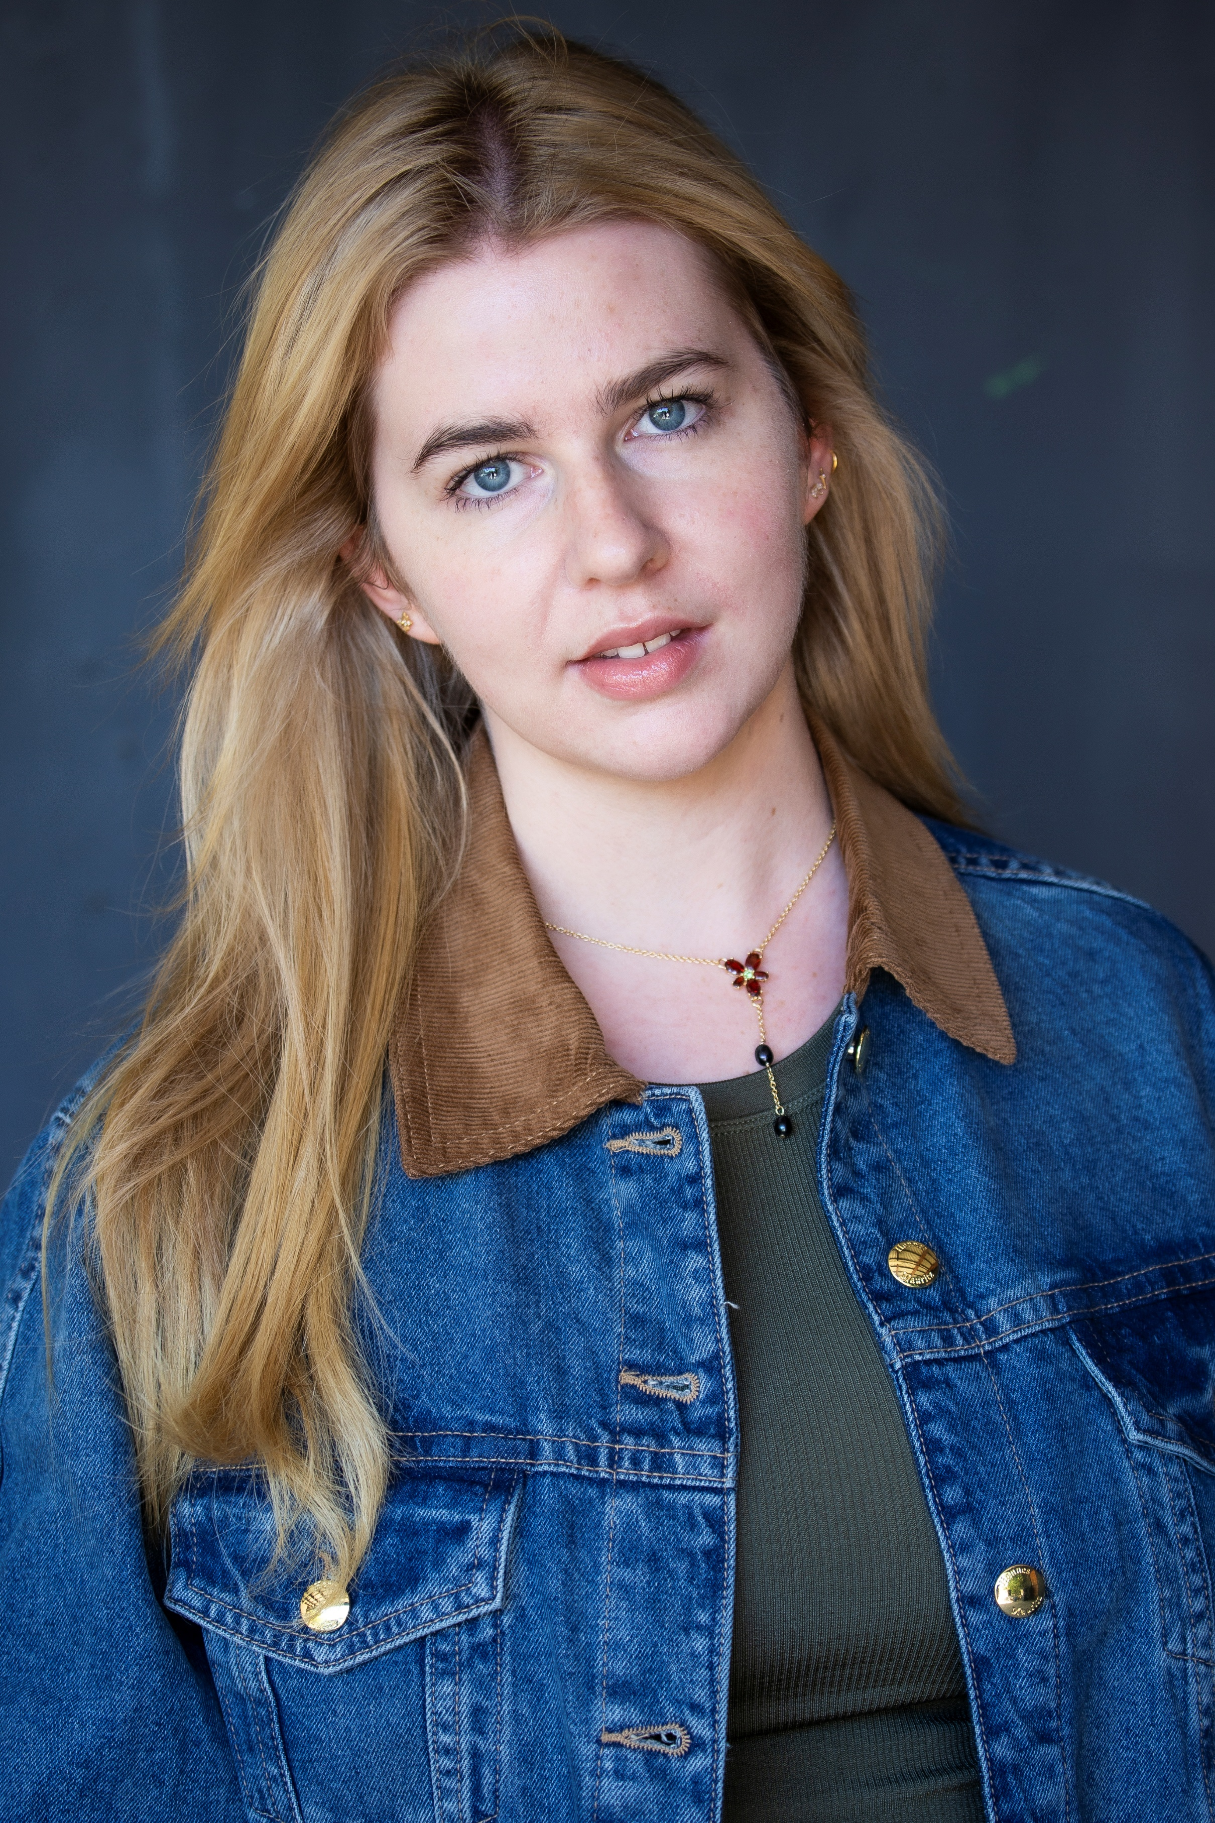 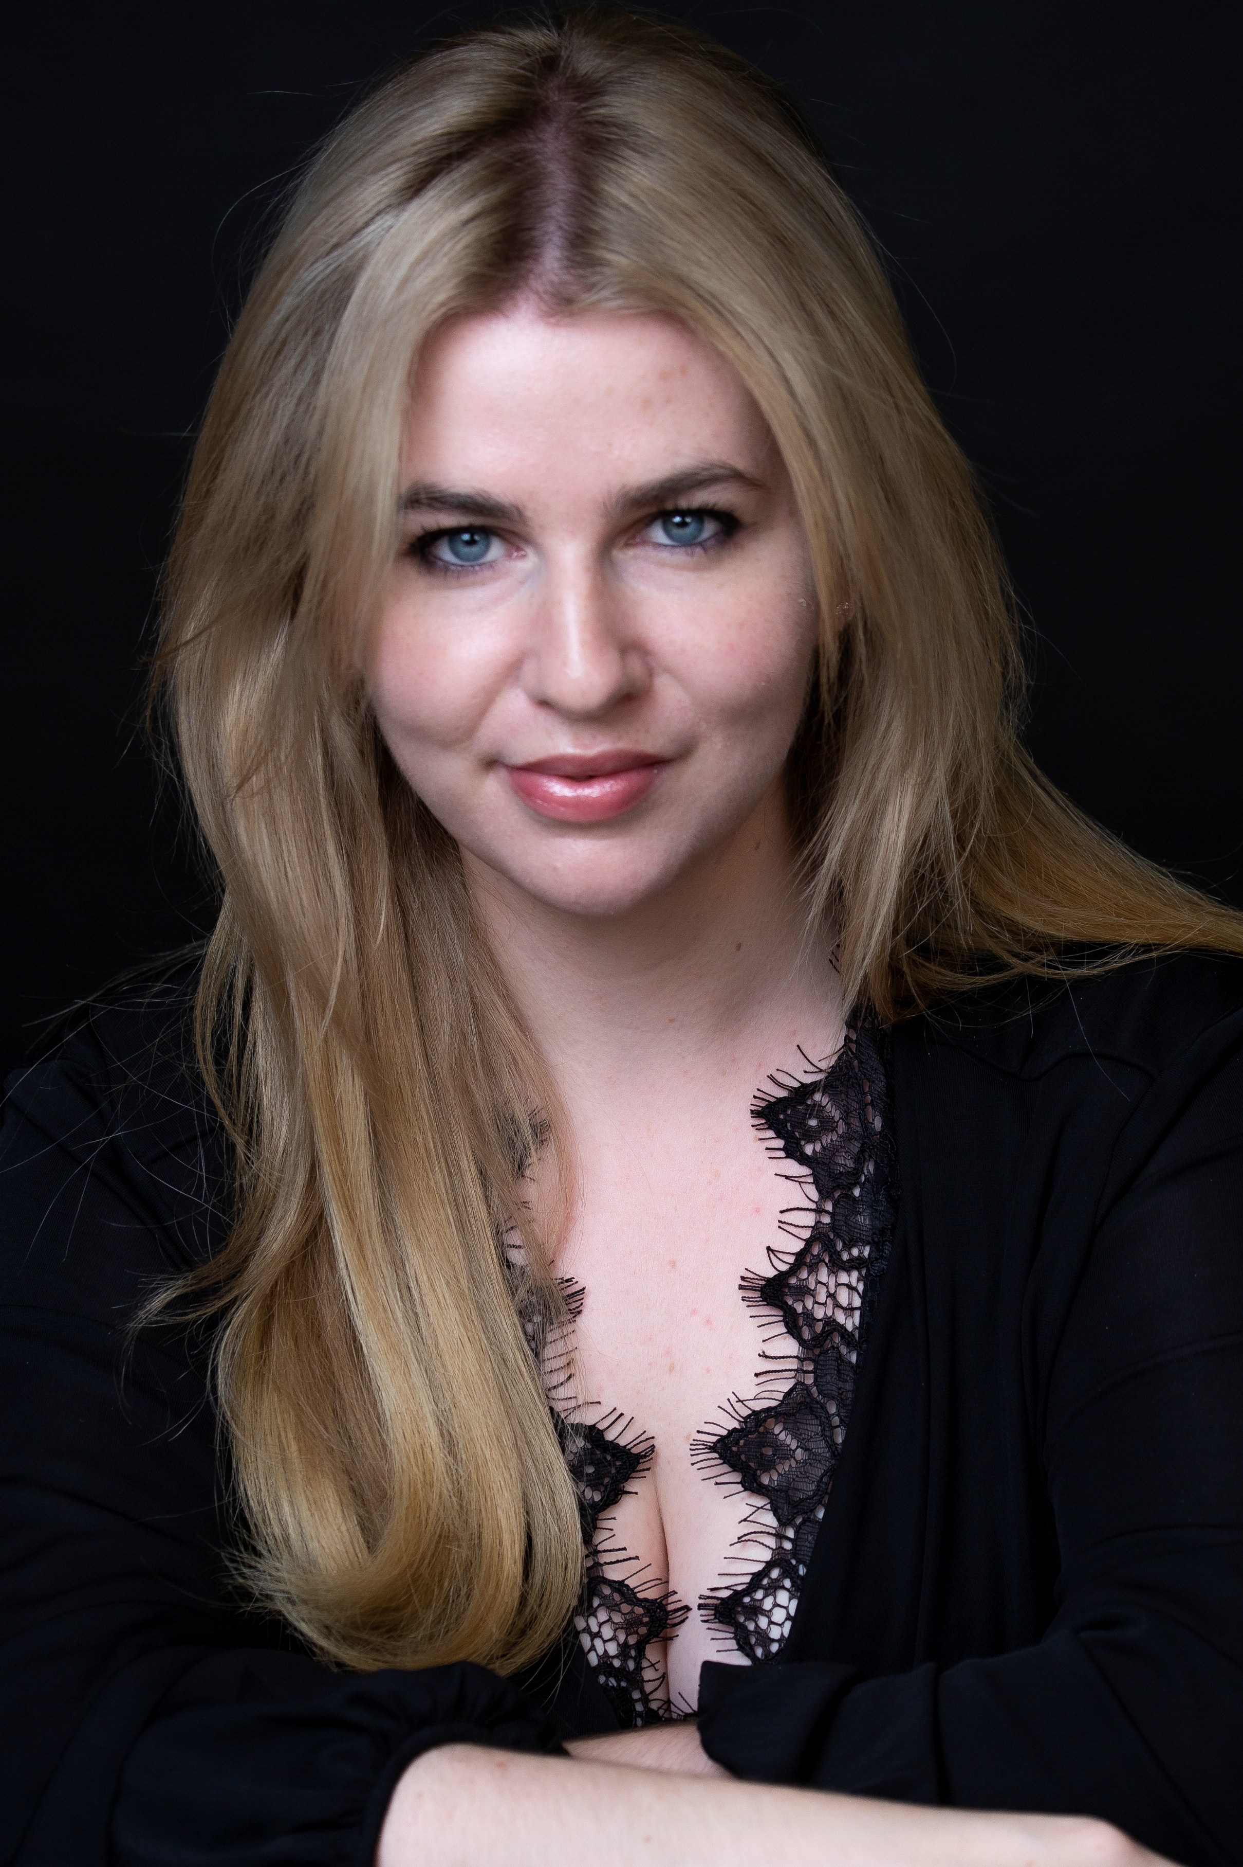 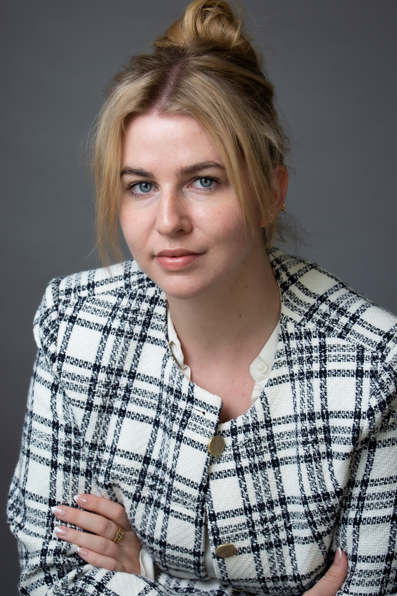
ACTOR | DANCER | MC | SINGER | VOICE OVER ARTIST
FILM & TV ROLE DIRECTOR / CHANNEL
2024 The Gallery Supporting Rachel Reynolds
2022 City Break Supporting Jordan Pascoe
2022 Agree to kill Supporting Nicola Hanekom
THEATRE ROLE DIRECTOR / VENUE
2021 Emotional truth Supporting Nicola Hanekom
TRAINING
Act Cape Town Film Acting Academy
Advanced Certificate in Acting for Film
London Academy of Music and Dramatic Arts
Trained for the Silver Medal examination with Tam Spiers and achieved a distinction in my examination
Act Cape Town Film Acting Academy
ACT Teens Course
FURTHER DETAILS
Appearance Hair: Blonde Eyes: Blue Clothing Size Top: S-M
Height: 167cm Shoe: 5 UK Clothing Size Bottom: M

Accents American (Standard), British (RP), British (Cockney), Polish

Language English, Afrikaans, German

Dance Modern, Zumba

Musical Piano

Niche Comic Timing, Stand- Up comedy, Axe Throwingf

Singing G3-C6
Alto

Sport Archery, Gym, Hoolahoop, Hiking, Ice skating, Kayaking, Netball, Pilates

